**REPORT FOR GY WEBSITE**

As a project work for course

**INTERNET PROGRAMMING LABORATRORY (CSE326)**

NAME :- Reshab Sharma

REGISTRATION NO :- 12215638

NAME :- M. Atish

REGISTRATION NO :- 12213412

PROGRAMM :-CSE B.TECH

SEMISTER :-FIRST

SCHOOL :-SCHOOL OF COMPUTER SCIENCE AND ENGENEERING

UNIVERSITY :-LOVELY PROFESSIONAL UNIVERSITY

DATE OF SUBMISSION :-05TH DECEMBER 2022



LOVELY PROFESSIONAL UNIVERSITY, JALANDHAR,PUNJAB,INDIA

|  |  |
| --- | --- |
| 1. ABSTRACT   1.2 Acknowledgement |  |
| 1. INTRODUCTION    1. CONTEXT    2. MOTIVATION   2.3 IDEA |  |
| 1. TEAM MEMBERS WITH ROLES    1. MEMBERS   3.2 CONTRIBUTIONS |  |
| 1. code |  |
| 5. Screenshots |  |
| 6.About Blood Donation |  |
| 7. References |  |

**TABLE OF CONTENTS**

**BLOOD DONATION WEBSITE**

***1.ABSTRACT:-***

This project Gym Management System has been developed on Python. The main aim of the python mini projects with documentations develop web application in college submission. In these modern days when people all over the world have become so much concerned about the be and diet it is but obvious that they continually seek out for Gym centre Gym Management System is an easy way to use gym and health gym member ship system. It can helps to keep records of members and their memberships, and give permit communication between members Gym Master is also feature-packed, helping members in the management and growth of health club This Gym Management System Project in python is very her easy to use gym centre. This gym management system has several things like user can register through our website, can check nutrition , can see the types of trainings etc…..

***1.1 ACKNOWLEDGEMENT:-***

I would like to thank my mentor – Geetika Sharma for her advice and inputs on this project. Many thanks to my friends and parents as well, who spent countless hours to listen and provide feedbacks.

**2.INTRODUCTION**

* 1. Context:-

This project has been done as part of my course for the CSE at Lovely professional university, supervised by Geethika Sharma.

* 1. Motivations

Being extremely interested in everything having a relation with the Machine Learning, the group project was a great occasion to give us the time to learn and confirm our interest for this field. The fact that we can check our blood donation website at an instant and later work in it .We can use programming almost everywhere. That’s why I decided to conduct my project into html.

* 1. Idea:-

As a first experience, we wanted to make my project as much didactic as possible by approaching every different steps of the python programming process and trying to understand them deeply. Known as ” toy problem” the problems that are not immediate scientific interest but useful to illustrate and practice, we chose to take house price Prediction as approach. The goal was to predict the price of a given house according to the market prices taking into account different “features” that will be developed in the following.

3.TEAM MEMBERS WITH ROLES:-

Member 1:-

Name :-Reshab Sharma

Contributions :-

1.Coding(joined)

2.Report

Member 2:-

Name :- M. Atish

Contribution :

1.coding for css

2.Report

**4.Code:-**

|  |  |
| --- | --- |
|  | <!DOCTYPE html> |
|  | <html lang="en"> |
|  |  |
|  | <head> |
|  | <meta charset="UTF-8"> |
|  | <meta http-equiv="X-UA-Compatible" content="IE=edge"> |
|  | <meta name="viewport" content="width=device-width, initial-scale=1.0"> |
|  | <title>Document</title> |
|  | </head> |
|  |  |
|  | <style> |
|  | body { |
|  | margin: 0px; |
|  | padding: 0px; |
|  | background-image: url('img/gym.jpg'); |
|  |  |
|  |  |
|  | } |
|  |  |
|  | h1 { |
|  | position: absolute; |
|  | left: 500px; |
|  | top: 350px; |
|  | } |
|  |  |
|  | .navbar { |
|  | display: inline-block; |
|  | margin-left: 300px; |
|  |  |
|  | } |
|  |  |
|  | .navbar li { |
|  | display: inline-block; |
|  | font-size: 15px; |
|  | } |
|  |  |
|  | .navbar li a { |
|  | color: black; |
|  | text-decoration: none; |
|  | padding: 20px; |
|  | } |
|  |  |
|  |  |
|  | .navbar li a:hover, |
|  | .navbar li a.active { |
|  | text-decoration: underline; |
|  | color: blue; |
|  | font-size: large; |
|  | } |
|  |  |
|  | button { |
|  | margin-top: 20px; |
|  | margin-left: 700px; |
|  | border-radius: 50px; |
|  | font-size: 20px; |
|  | } |
|  |  |
|  | button a:hover, |
|  | button a:active { |
|  | font-size: 30px; |
|  | color: goldenrod; |
|  | text-decoration: wavy; |
|  | } |
|  |  |
|  |  |
|  |  |
|  | </style> |
|  |  |
|  | <body> |
|  |  |
|  |  |
|  | <header class="header"> |
|  | <div class="navbar"> |
|  | <ul class="navbar"> |
|  | <li> <a href="#">Home</a> </li> |
|  | <li><a href="about.html">About us</a> </li> |
|  | <li><a href="trainings.html">Trainings</a></li> |
|  | <li><a href="timetable.html">Timetable</a></li> |
|  | <li><a href="nutrition.html">Nutrition</a></li> |
|  | <li><a href="gallery.html">Gallery</a> </li> |
|  | <h1 style="font-size:100px;"><i>Fitness Club</i></h1> |
|  |  |
|  |  |
|  |  |
|  | </ul> |
|  | </div> |
|  |  |
|  | </div> |
|  |  |
|  | </header> |
|  |  |
|  | <button><a href="register.html"> Click here for Registation </a></button> |
|  |  |
|  |  |
|  | </body> |
|  |  |
|  | </html> |

**CODE FOR ABOUT US:-**

|  |  |
| --- | --- |
|  | <!DOCTYPE html> |
|  | <html lang="en"> |
|  |  |
|  | <head> |
|  | <meta charset="UTF-8"> |
|  | <meta http-equiv="X-UA-Compatible" content="IE=edge"> |
|  | <meta name="viewport" content="width=device-width, initial-scale=1.0"> |
|  | <title>Document</title> |
|  | </head> |
|  | <style> |
|  | body { |
|  | background: url('img/about.jpg'); |
|  |  |
|  | } |
|  |  |
|  | h1 { |
|  | font-size: 50px; |
|  | font-family: 'Lucida Sans', 'Lucida Sans Regular', 'Lucida Grande', 'Lucida Sans Unicode', Geneva, Verdana, sans-serif; |
|  | text-decoration: underline; |
|  | text-align: center; |
|  | color: burlywood; |
|  | } |
|  |  |
|  | h2 { |
|  | font-size: 60px; |
|  | margin-left: 30px; |
|  | margin-top: 30px; |
|  | color: aqua; |
|  | } |
|  |  |
|  | h3 { |
|  | font-size: 35px; |
|  | color: white; |
|  | font-family: 'Segoe UI', Tahoma, Geneva, Verdana, sans-serif; |
|  |  |
|  | } |
|  |  |
|  | h4 { |
|  | font-size: 20px; |
|  | color: rgb(255, 140, 0); |
|  |  |
|  | } |
|  |  |
|  | h5 { |
|  | font-size: 20px; |
|  | font-style: oblique; |
|  | } |
|  |  |
|  | .navbar { |
|  | display: inline-block; |
|  | margin: auto; |
|  | } |
|  |  |
|  | .navbar li { |
|  | display: inline-block; |
|  | font-size: 10px; |
|  | } |
|  |  |
|  | .navbar li a { |
|  | color: black; |
|  | text-decoration: none; |
|  | padding: 10px; |
|  | } |
|  |  |
|  | .navbar li a:hover, |
|  | .navbar li a.active { |
|  | text-decoration: underline; |
|  | color: goldenrod; |
|  | font-size: large; |
|  | } |
|  |  |
|  | button { |
|  |  |
|  | border-radius: 50px; |
|  | } |
|  |  |
|  | button a:hover, |
|  | button a:active { |
|  | font-size: 30px; |
|  | color: goldenrod; |
|  | text-decoration: wavy; |
|  | } |
|  | </style> |
|  |  |
|  | <body> |
|  | <div class="navbar"> |
|  | <ul class="navbar"> |
|  | <li> <button type="button"><a href="fitness.html">Home</a></button></li> |
|  | <li><button type="button"><a href="trainings.html">Trainings</a></button></li> |
|  | <li> <button type="button"><a href="timetable.html">Timetable</a></button></li> |
|  | <li> <button type="button"><a href="nutrition.html">Nutrition</a></button></li> |
|  | <li> <button type="button"><a href="gallery.html">Gallery</a></button></li> |
|  | </ul> |
|  | </div> |
|  | <pre> |
|  | <button><a href="register.html"> Click here for Registation </a></button> |
|  | </pre> |
|  | <h1> About Us |
|  |  |
|  | </h1> |
|  | <h2>WE ARE GYM AND FITNESS</h2> |
|  | <h3> |
|  | <pre>Helping people live longer, |
|  | happier and healthier lives for over 20 years.</pre> |
|  | </h3> |
|  | <h4> |
|  | <pre>Gym and Fitness was founded in 2002 as a family owned and operated |
|  | business specialising in supplying high-quality gym equipment at great prices.</pre> |
|  | </h4> |
|  | <h5> |
|  | <pre style="color: black;"> |
|  | Instead of being just another gym equipment retailer, our founders wanted to be |
|  | the best in the industry and set their minds to doing so! |
|  | Over the last two decades Gym and Fitness has grown into one of Punjab's |
|  | largest online fitness equipment retailers, |
|  | helping thousands of customers live longer, happier and healthier lives.</pre> |
|  | </h5> |
|  |  |
|  |  |
|  |  |
|  | </body> |
|  |  |
|  | </html> |

**CODE FOR NUTRITION INFORMATION:-**

|  |  |
| --- | --- |
|  | <!DOCTYPE html> |
|  | <html lang="en"> |
|  |  |
|  | <head> |
|  | <meta charset="UTF-8"> |
|  | <meta http-equiv="X-UA-Compatible" content="IE=edge"> |
|  | <meta name="viewport" content="width=device-width, initial-scale=1.0"> |
|  | <title>Document</title> |
|  | </head> |
|  | <style> |
|  | body { |
|  | background-color: whitesmoke; |
|  |  |
|  |  |
|  | } |
|  |  |
|  | .item { |
|  | margin-top: -1640px; |
|  | margin-left: 700px; |
|  | } |
|  |  |
|  | h1 { |
|  | text-align: center; |
|  | color: rgb(110, 165, 42); |
|  | font-size: 50px; |
|  | text-decoration: underline; |
|  | } |
|  |  |
|  | h2 { |
|  | margin-top: 10px; |
|  | margin-left: 610px; |
|  | font-size: 30px; |
|  | } |
|  |  |
|  | h3 { |
|  | margin-top: -61px; |
|  |  |
|  | font-size: 30px; |
|  | } |
|  |  |
|  | .navbar { |
|  | display: inline-block; |
|  | } |
|  |  |
|  | .navbar li { |
|  | display: inline-block; |
|  | font-size: 10px; |
|  | } |
|  |  |
|  | .navbar li a { |
|  | color: black; |
|  | text-decoration: none; |
|  | padding: 5px; |
|  | } |
|  |  |
|  | .navbar li a:hover, |
|  | .navbar li a.active { |
|  | text-decoration: underline; |
|  | color: goldenrod; |
|  | font-size: large; |
|  | } |
|  |  |
|  | button { |
|  |  |
|  | border-radius: 50px; |
|  | } |
|  |  |
|  | button a:hover, |
|  | button a:active { |
|  | font-size: 30px; |
|  | color: goldenrod; |
|  | text-decoration: wavy; |
|  | } |
|  | </style> |
|  |  |
|  | <body> |
|  | <div class="navbar"> |
|  | <ul class="navbar"> |
|  | <li> <button type="button"><a href="fitness.html">Home</a></button></li> |
|  | <li> <button type="button"><a href="about.html">About Us</a></button></li> |
|  | <li><button type="button"><a href="trainings.html">Trainings</a></button></li> |
|  | <li> <button type="button"><a href="timetable.html">Timetable</a></button></li> |
|  | <li> <button type="button"><a href="gallery.html">Gallery</a></button></li> |
|  | </ul> |
|  | </div><br> |
|  | <pre> <button><a href="register.html"> Click here for Registation </a></button> |
|  | </pre> |
|  | <h1>NUTRITION</h1> |
|  | <h2>𝕊𝕠𝕦𝕣𝕔𝕖𝕤 𝕠𝕗 𝕡𝕣𝕠𝕥𝕖𝕚𝕟 𝕗𝕠𝕣 ℕ𝕠𝕟-𝕍𝕖𝕘𝕖𝕥𝕒𝕣𝕚𝕒𝕟𝕤</h2> |
|  | <h3> 𝕊𝕠𝕦𝕣𝕔𝕖𝕤 𝕠𝕗 𝕡𝕣𝕠𝕥𝕖𝕚𝕟 𝕗𝕠𝕣 𝕍𝕖𝕘𝕖𝕥𝕒𝕣𝕚𝕒𝕟𝕤</h3> |
|  |  |
|  | <ol> |
|  | <li>𝐋𝐞𝐧𝐭𝐢𝐥𝐬</li> |
|  | <ul type="circle"> |
|  | <li>𝐏𝐫𝐨𝐭𝐞𝐢𝐧 𝐂𝐨𝐧𝐭𝐞𝐧𝐭- 𝟗𝐠𝐦</li> |
|  | <li>𝐂𝐚𝐥𝐨𝐫𝐢𝐞 𝐂𝐨𝐧𝐭𝐞𝐧𝐭- 𝟏𝟏𝟓𝐊𝐜𝐚𝐥</li> |
|  | <li>𝐃𝐢𝐞𝐭- 𝐒𝐢𝐦𝐩𝐥𝐲 𝐛𝐚𝐤𝐞𝐝 𝐚𝐧𝐝 𝐥𝐢𝐠𝐡𝐭𝐥𝐲 𝐬𝐞𝐚𝐬𝐨𝐧𝐞𝐝, 𝐬𝐨𝐮𝐩, 𝐬𝐭𝐞𝐰</li> |
|  | </ul> |
|  | <li>𝐄𝐝𝐚𝐦𝐚𝐦𝐞 𝐁𝐞𝐚𝐧𝐬</li> |
|  | <ul type="circle"> |
|  | <li>𝐏𝐫𝐨𝐭𝐞𝐢𝐧 𝐂𝐨𝐧𝐭𝐞𝐧𝐭- 𝟏𝟏𝐠𝐦</li> |
|  | <li>𝐂𝐚𝐥𝐨𝐫𝐢𝐞 𝐂𝐨𝐧𝐭𝐞𝐧𝐭- 𝟏𝟏𝟐𝐊𝐜𝐚𝐥</li> |
|  | <li>𝐃𝐢𝐞𝐭- 𝐑𝐨𝐚𝐬𝐭𝐞𝐝 𝐚𝐧𝐝 𝐥𝐢𝐠𝐡𝐭𝐥𝐲 𝐬𝐞𝐚𝐬𝐨𝐧𝐞𝐝, 𝐡𝐮𝐦𝐦𝐮𝐬, 𝐬𝐚𝐥𝐚𝐝</li> |
|  | </ul> |
|  | <li>𝐆𝐫𝐞𝐞𝐧 𝐩𝐞𝐚𝐬</li> |
|  | <ul type="circle"> |
|  | <li>𝐏𝐫𝐨𝐭𝐞𝐢𝐧 𝐂𝐨𝐧𝐭𝐞𝐧𝐭- 𝟓𝐠𝐦</li> |
|  | <li>𝐂𝐚𝐥𝐨𝐫𝐢𝐞 𝐂𝐨𝐧𝐭𝐞𝐧𝐭- 𝟖𝟒𝐊𝐜𝐚𝐥</li> |
|  | <li>𝐃𝐢𝐞𝐭- 𝐜𝐮𝐭𝐥𝐞𝐭𝐬, 𝐬𝐚𝐧𝐝𝐰𝐢𝐜𝐡𝐞𝐬, 𝐬𝐨𝐮𝐩</li> |
|  | </ul> |
|  | <li>𝐁𝐥𝐚𝐜𝐤 𝐛𝐞𝐚𝐧𝐬</li> |
|  | <ul type="circle"> |
|  | <li>𝐏𝐫𝐨𝐭𝐞𝐢𝐧 𝐂𝐨𝐧𝐭𝐞𝐧𝐭- 𝟗𝐠𝐦</li> |
|  | <li>𝐂𝐚𝐥𝐨𝐫𝐢𝐞 𝐂𝐨𝐧𝐭𝐞𝐧𝐭- 𝟏𝟑𝟐𝐊𝐜𝐚𝐥</li> |
|  | <li>𝐃𝐢𝐞𝐭- 𝐛𝐮𝐫𝐫𝐢𝐭𝐨𝐬, 𝐬𝐚𝐥𝐚𝐝𝐬</li> |
|  | </ul> |
|  | <li>𝐁𝐥𝐚𝐜𝐤-𝐞𝐲𝐞𝐝 𝐛𝐞𝐚𝐧𝐬</li> |
|  | <ul type="circle"> |
|  | <li>𝐏𝐫𝐨𝐭𝐞𝐢𝐧 𝐂𝐨𝐧𝐭𝐞𝐧𝐭- 𝟖𝐠𝐦</li> |
|  | <li>𝐂𝐚𝐥𝐨𝐫𝐢𝐞 𝐂𝐨𝐧𝐭𝐞𝐧𝐭- 𝟏𝟏𝟒𝐊𝐜𝐚𝐥</li> |
|  | <li>𝐃𝐢𝐞𝐭- 𝐜𝐮𝐫𝐫𝐲</li> |
|  | </ul> |
|  | <li>𝐁𝐚𝐤𝐞𝐝 𝐛𝐞𝐚𝐧𝐬</li> |
|  | <ul type="circle"> |
|  | <li>𝐏𝐫𝐨𝐭𝐞𝐢𝐧 𝐂𝐨𝐧𝐭𝐞𝐧𝐭- 𝟓𝐠𝐦</li> |
|  | <li>𝐂𝐚𝐥𝐨𝐫𝐢𝐞 𝐂𝐨𝐧𝐭𝐞𝐧𝐭- 𝟏𝟎𝟓𝐊𝐜𝐚𝐥</li> |
|  | <li>𝐃𝐢𝐞𝐭- 𝐬𝐚𝐥𝐚𝐝𝐬, 𝐭𝐚𝐜𝐨𝐬</li> |
|  | </ul> |
|  | <li>𝐂𝐡𝐢𝐜𝐤𝐩𝐞𝐚𝐬</li> |
|  | <ul type="circle"> |
|  | <li>𝐏𝐫𝐨𝐭𝐞𝐢𝐧 𝐂𝐨𝐧𝐭𝐞𝐧𝐭- 𝟗𝐠𝐦</li> |
|  | <li>𝐂𝐚𝐥𝐨𝐫𝐢𝐞 𝐂𝐨𝐧𝐭𝐞𝐧𝐭- 𝟏𝟔𝟒𝐊𝐜𝐚𝐥</li> |
|  | <li>𝐃𝐢𝐞𝐭- 𝐜𝐮𝐫𝐫𝐲</li> |
|  | </ul> |
|  | <li>𝐐𝐮𝐢𝐧𝐨𝐚</li> |
|  | <ul type="circle"> |
|  | <li>𝐏𝐫𝐨𝐭𝐞𝐢𝐧 𝐂𝐨𝐧𝐭𝐞𝐧𝐭- 𝟒𝐠𝐦</li> |
|  | <li>𝐂𝐚𝐥𝐨𝐫𝐢𝐞 𝐂𝐨𝐧𝐭𝐞𝐧𝐭- 𝟏𝟐𝟎𝐊𝐜𝐚𝐥</li> |
|  | <li>𝐃𝐢𝐞𝐭- 𝐬𝐚𝐥𝐚𝐝𝐬, 𝐮𝐩𝐦𝐚, 𝐬𝐨𝐮𝐩, 𝐩𝐮𝐥𝐚𝐨</li> |
|  | </ul> |
|  | <li>𝐍𝐚𝐯𝐲 𝐛𝐞𝐚𝐧𝐬</li> |
|  | <ul type="circle"> |
|  | <li>𝐏𝐫𝐨𝐭𝐞𝐢𝐧 𝐂𝐨𝐧𝐭𝐞𝐧𝐭- 𝟔𝐠𝐦</li> |
|  | <li>𝐂𝐚𝐥𝐨𝐫𝐢𝐞 𝐂𝐨𝐧𝐭𝐞𝐧𝐭- 𝟔𝟕𝐊𝐜𝐚𝐥</li> |
|  | <li>𝐃𝐢𝐞𝐭- 𝐬𝐚𝐥𝐚𝐝𝐬, 𝐬𝐨𝐮𝐩, 𝐡𝐮𝐦𝐦𝐮𝐬</li> |
|  | </ul> |
|  | <li>𝐂𝐡𝐢𝐚 𝐬𝐞𝐞𝐝𝐬</li> |
|  | <ul type="circle"> |
|  | <li>𝐏𝐫𝐨𝐭𝐞𝐢𝐧 𝐂𝐨𝐧𝐭𝐞𝐧𝐭- 𝟏𝟔𝐠𝐦</li> |
|  | <li>𝐂𝐚𝐥𝐨𝐫𝐢𝐞 𝐂𝐨𝐧𝐭𝐞𝐧𝐭-𝟒𝟗𝟎𝐊𝐜𝐚𝐥</li> |
|  | <li>𝐃𝐢𝐞𝐭- 𝐩𝐮𝐝𝐝𝐢𝐧𝐠, 𝐠𝐫𝐨𝐮𝐧𝐝𝐞𝐝 𝐢𝐧𝐭𝐨 𝐬𝐦𝐨𝐨𝐭𝐡𝐢𝐞𝐬, 𝐣𝐮𝐢𝐜𝐞𝐬, 𝐚𝐧𝐝 |
|  | 𝐬𝐚𝐥𝐚𝐝𝐬</li> |
|  | </ul> |
|  | <li>𝐆𝐫𝐞𝐞𝐤 𝐲𝐨𝐠𝐡𝐮𝐫𝐭</li> |
|  | <ul type="circle"> |
|  | <li>𝐏𝐫𝐨𝐭𝐞𝐢𝐧 𝐂𝐨𝐧𝐭𝐞𝐧𝐭- 𝟏𝟏𝐠𝐦</li> |
|  | <li>𝐂𝐚𝐥𝐨𝐫𝐢𝐞 𝐂𝐨𝐧𝐭𝐞𝐧𝐭- 𝟔𝟗𝐊𝐜𝐚𝐥</li> |
|  | <li>𝐃𝐢𝐞𝐭- 𝐞𝐚𝐭𝐞𝐧 𝐚𝐬 𝐢𝐭 𝐢𝐬</li> |
|  | </ul> |
|  | <li>𝐕𝐢𝐭𝐚𝐥 𝐰𝐡𝐞𝐚𝐭 𝐠𝐥𝐮𝐭𝐞𝐧</li> |
|  | <ul type="circle"> |
|  | <li>𝐏𝐫𝐨𝐭𝐞𝐢𝐧 𝐂𝐨𝐧𝐭𝐞𝐧𝐭- 𝟕𝟓𝐠𝐦 </li> |
|  | <li>𝐂𝐚𝐥𝐨𝐫𝐢𝐞 𝐂𝐨𝐧𝐭𝐞𝐧𝐭- 𝟑𝟕𝟎𝐊𝐜𝐚𝐥</li> |
|  | <li>𝐃𝐢𝐞𝐭- 𝐬𝐞𝐢𝐭𝐚𝐧</li> |
|  | </ul> |
|  | <li>𝐂𝐨𝐭𝐭𝐚𝐠𝐞 𝐜𝐡𝐞𝐞𝐬𝐞</li> |
|  | <ul type="circle"> |
|  | <li>𝐏𝐫𝐨𝐭𝐞𝐢𝐧 𝐂𝐨𝐧𝐭𝐞𝐧𝐭- 𝟏𝟐𝐠𝐦</li> |
|  | <li>𝐂𝐚𝐥𝐨𝐫𝐢𝐞 𝐂𝐨𝐧𝐭𝐞𝐧𝐭- 𝟕𝟐𝐊𝐜𝐚𝐥</li> |
|  | <li>𝐃𝐢𝐞𝐭- 𝐜𝐮𝐫𝐫𝐲, 𝐬𝐚𝐧𝐝𝐰𝐢𝐜𝐡𝐞𝐬, 𝐫𝐨𝐚𝐬𝐭𝐞𝐝 𝐚𝐧𝐝 𝐥𝐢𝐠𝐡𝐭𝐥𝐲 𝐬𝐞𝐚𝐬𝐨𝐧𝐞𝐝</li> |
|  | </ul> |
|  | <li>𝐓𝐨𝐟𝐮</li> |
|  | <ul type="circle"> |
|  | <li>𝐏𝐫𝐨𝐭𝐞𝐢𝐧 𝐂𝐨𝐧𝐭𝐞𝐧𝐭- 𝟖𝐠𝐦</li> |
|  | <li>𝐂𝐚𝐥𝐨𝐫𝐢𝐞 𝐂𝐨𝐧𝐭𝐞𝐧𝐭- 𝟕𝟔𝐊𝐜𝐚𝐥</li> |
|  | <li>𝐃𝐢𝐞𝐭- 𝐫𝐨𝐚𝐬𝐭𝐞𝐝 𝐚𝐧𝐝 𝐬𝐞𝐚𝐬𝐨𝐧𝐞𝐝 𝐰𝐢𝐭𝐡 𝐬𝐩𝐢𝐜𝐞𝐬, 𝐛𝐚𝐤𝐞𝐝</li> |
|  | </ul> |
|  | <li>𝐂𝐚𝐬𝐡𝐞𝐰 𝐧𝐮𝐭𝐬</li> |
|  | <ul type="circle"> |
|  | <li>𝐏𝐫𝐨𝐭𝐞𝐢𝐧 𝐂𝐨𝐧𝐭𝐞𝐧𝐭- 𝟏𝟖𝐠𝐦</li> |
|  | <li>𝐂𝐚𝐥𝐨𝐫𝐢𝐞 𝐂𝐨𝐧𝐭𝐞𝐧𝐭- 𝟓𝟓𝟑𝐊𝐜𝐚𝐥</li> |
|  | <li>𝐃𝐢𝐞𝐭- 𝐫𝐨𝐚𝐬𝐭𝐞𝐝, 𝐬𝐚𝐥𝐭𝐞𝐝, 𝐬𝐩𝐢𝐜𝐞𝐝, 𝐛𝐚𝐤𝐞𝐝</li> |
|  | </ul> |
|  | <li>𝐏𝐞𝐚𝐧𝐮𝐭𝐬</li> |
|  | <ul type="circle"> |
|  | <li>𝐏𝐫𝐨𝐭𝐞𝐢𝐧 𝐂𝐨𝐧𝐭𝐞𝐧𝐭- 𝟐𝟖𝐠𝐦</li> |
|  | <li>𝐂𝐚𝐥𝐨𝐫𝐢𝐞 𝐂𝐨𝐧𝐭𝐞𝐧𝐭- 𝟓𝟗𝟗𝐊𝐜𝐚𝐥</li> |
|  | <li>𝐃𝐢𝐞𝐭- 𝐫𝐨𝐚𝐬𝐭𝐞𝐝, 𝐬𝐚𝐥𝐭𝐞𝐝, 𝐬𝐩𝐢𝐜𝐞𝐝, 𝐛𝐚𝐤𝐞𝐝</li> |
|  | </ul> |
|  | <li>𝐀𝐥𝐦𝐨𝐧𝐝𝐬</li> |
|  | <ul type="circle"> |
|  | <li>𝐏𝐫𝐨𝐭𝐞𝐢𝐧 𝐂𝐨𝐧𝐭𝐞𝐧𝐭- 𝟐𝟏𝐠𝐦</li> |
|  | <li>𝐂𝐚𝐥𝐨𝐫𝐢𝐞 𝐂𝐨𝐧𝐭𝐞𝐧𝐭- 𝟓𝟕𝟓𝐊𝐜𝐚𝐥</li> |
|  | <li>𝐃𝐢𝐞𝐭- 𝐫𝐨𝐚𝐬𝐭𝐞𝐝, 𝐬𝐚𝐥𝐭𝐞𝐝, 𝐬𝐩𝐢𝐜𝐞𝐝, 𝐛𝐚𝐤𝐞𝐝</li> |
|  | </ul> |
|  | <li>𝐏𝐞𝐚𝐧𝐮𝐭 𝐛𝐮𝐭𝐭𝐞𝐫</li> |
|  | <ul type="circle"> |
|  | <li>𝐏𝐫𝐨𝐭𝐞𝐢𝐧 𝐂𝐨𝐧𝐭𝐞𝐧𝐭- 𝟐𝟓𝐠𝐦</li> |
|  | <li>𝐂𝐚𝐥𝐨𝐫𝐢𝐞 𝐂𝐨𝐧𝐭𝐞𝐧𝐭- 𝟓𝟖𝟖𝐊𝐜𝐚𝐥</li> |
|  | <li>𝐃𝐢𝐞𝐭- 𝐰𝐢𝐭𝐡 𝐛𝐫𝐞𝐚𝐝, 𝐦𝐢𝐥𝐤𝐬𝐡𝐚𝐤𝐞𝐬, 𝐢𝐜𝐞-𝐜𝐫𝐞𝐚𝐦𝐬, 𝐚𝐬 𝐢𝐭 𝐢𝐬</li> |
|  | </ul> |
|  | <li>𝐏𝐚𝐫𝐦𝐞𝐬𝐚𝐧 𝐜𝐡𝐞𝐞𝐬𝐞</li> |
|  | <ul type="circle"> |
|  | <li>𝐏𝐫𝐨𝐭𝐞𝐢𝐧 𝐂𝐨𝐧𝐭𝐞𝐧𝐭- 𝟑𝟗𝐠𝐦</li> |
|  | <li>𝐂𝐚𝐥𝐨𝐫𝐢𝐞 𝐂𝐨𝐧𝐭𝐞𝐧𝐭- 𝟑𝟗𝟐 𝐊𝐜𝐚𝐥</li> |
|  | <li>𝐃𝐢𝐞𝐭- 𝐬𝐩𝐚𝐠𝐡𝐞𝐭𝐭𝐢, 𝐩𝐚𝐫𝐦𝐞𝐬𝐚𝐧 𝐛𝐮𝐭𝐭𝐞𝐫 𝐬𝐚𝐮𝐜𝐞 𝐰𝐢𝐭𝐡 𝐫𝐨𝐚𝐬𝐭𝐞𝐝 |
|  | 𝐯𝐞𝐠𝐞𝐭𝐚𝐛𝐥𝐞𝐬</li> |
|  | </ul> |
|  | <li>𝐂𝐡𝐞𝐝𝐝𝐚𝐫 𝐜𝐡𝐞𝐞𝐬𝐞</li> |
|  | <ul type="circle"> |
|  | <li>𝐏𝐫𝐨𝐭𝐞𝐢𝐧 𝐂𝐨𝐧𝐭𝐞𝐧𝐭- 𝟐𝟓𝐠𝐦</li> |
|  | 𝐂𝐚𝐥𝐨𝐫𝐢𝐞 𝐂𝐨𝐧𝐭𝐞𝐧𝐭- 𝟒𝟎𝟑𝐊𝐜𝐚𝐥</li> |
|  | 𝐃𝐢𝐞𝐭- 𝐦𝐚𝐜𝐚𝐫𝐨𝐧𝐢, 𝐬𝐚𝐧𝐝𝐰𝐢𝐜𝐡𝐞𝐬, 𝐛𝐮𝐫𝐠𝐞𝐫𝐬</li> |
|  | </ul> |
|  | <li>𝐄𝐝𝐚𝐦 𝐜𝐡𝐞𝐞𝐬𝐞</li> |
|  | <ul type="circle"> |
|  | <li>𝐏𝐫𝐨𝐭𝐞𝐢𝐧 𝐂𝐨𝐧𝐭𝐞𝐧𝐭- 𝟐𝟓𝐠𝐦</li> |
|  | <li>𝐂𝐚𝐥𝐨𝐫𝐢𝐞 𝐂𝐨𝐧𝐭𝐞𝐧𝐭- 𝟑𝟓𝟕𝐊𝐜𝐚𝐥</li> |
|  | <li>𝐃𝐢𝐞𝐭- 𝐩𝐢𝐳𝐳𝐚, 𝐠𝐚𝐫𝐥𝐢𝐜 𝐛𝐫𝐞𝐚𝐝, 𝐥𝐚𝐬𝐚𝐠𝐧𝐚, 𝐫𝐢𝐬𝐨𝐭𝐭𝐨</li> |
|  | </ul> |
|  | <li>𝐓𝐞𝐦𝐩𝐞𝐡 𝐜𝐡𝐞𝐞𝐬𝐞</li> |
|  | <ul type="circle"> |
|  | <li> 𝐏𝐫𝐨𝐭𝐞𝐢𝐧 𝐂𝐨𝐧𝐭𝐞𝐧𝐭- 𝟏𝟗𝐠𝐦</li> |
|  | <li>𝐂𝐚𝐥𝐨𝐫𝐢𝐞 𝐂𝐨𝐧𝐭𝐞𝐧𝐭- 𝟏𝟗𝟑𝐊𝐜𝐚𝐥</li> |
|  | <li>𝐃𝐢𝐞𝐭- 𝐦𝐚𝐜 𝐧 𝐜𝐡𝐞𝐞𝐬𝐞, 𝐭𝐚𝐜𝐨𝐬, 𝐛𝐮𝐫𝐠𝐞𝐫𝐬, 𝐬𝐭𝐮𝐟𝐟𝐞𝐝 𝐜𝐚𝐩𝐬𝐢𝐜𝐮𝐦</li> |
|  | </ul> |
|  | </ol> |
|  | <div class="item"> |
|  |  |
|  | <ol> |
|  | <li>𝐂𝐡𝐢𝐜𝐤𝐞𝐧 𝐛𝐫𝐞𝐚𝐬𝐭 |
|  | <ul type="circle"> |
|  | <li>𝐏𝐫𝐨𝐭𝐞𝐢𝐧 𝐂𝐨𝐧𝐭𝐞𝐧𝐭- 𝟐𝟑.𝟓𝐠𝐦</li> |
|  | <li>𝐂𝐚𝐥𝐨𝐫𝐢𝐞 𝐂𝐨𝐧𝐭𝐞𝐧𝐭- 𝟏𝟗𝟓𝐊𝐜𝐚𝐥</li> |
|  | <li>𝐃𝐢𝐞𝐭- 𝐒𝐢𝐦𝐩𝐥𝐲 𝐛𝐚𝐤𝐞𝐝 𝐚𝐧𝐝 𝐥𝐢𝐠𝐡𝐭𝐥𝐲 𝐬𝐞𝐚𝐬𝐨𝐧𝐞𝐝, 𝐬𝐨𝐮𝐩, 𝐬𝐭𝐞𝐰, |
|  | 𝐜𝐮𝐫𝐫𝐲, 𝐫𝐨𝐚𝐬𝐭𝐞𝐝 𝐚𝐧𝐝 𝐬𝐩𝐢𝐜𝐞𝐝</li> |
|  | </ul> |
|  | <li>𝐄𝐠𝐠 𝐖𝐡𝐢𝐭𝐞𝐬</li> |
|  | <ul type="circle"> |
|  | <li>𝐂𝐚𝐥𝐨𝐫𝐢𝐞 𝐂𝐨𝐧𝐭𝐞𝐧𝐭- 𝟓𝟐𝐊𝐜𝐚𝐥</li> |
|  | <li>𝐃𝐢𝐞𝐭- 𝐛𝐨𝐢𝐥𝐞𝐝, 𝐬𝐜𝐫𝐚𝐦𝐛𝐥𝐞𝐝, 𝐬𝐨𝐮𝐟𝐟𝐥𝐞</li> |
|  | </ul> |
|  | <li>𝐂𝐡𝐢𝐜𝐤𝐞𝐧 𝐥𝐢𝐯𝐞𝐫</li> |
|  | <ul type="circle"> |
|  | <li>𝐏𝐫𝐨𝐭𝐞𝐢𝐧 𝐂𝐨𝐧𝐭𝐞𝐧𝐭- 𝟐𝟒𝐠𝐦</li> |
|  | <li>𝐂𝐚𝐥𝐨𝐫𝐢𝐞 𝐂𝐨𝐧𝐭𝐞𝐧𝐭- 𝟏𝟔𝟕𝐊𝐜𝐚𝐥</li> |
|  | <li>𝐃𝐢𝐞𝐭- 𝐟𝐫𝐢𝐞𝐝, 𝐫𝐨𝐚𝐬𝐭𝐞𝐝 𝐚𝐧𝐝 𝐬𝐞𝐚𝐬𝐨𝐧𝐞𝐝 𝐰𝐢𝐭𝐡 𝐬𝐩𝐢𝐜𝐞𝐬</li> |
|  | </ul> |
|  | <li>𝐒𝐚𝐥𝐦𝐨𝐧</li> |
|  | <ul type="circle"> |
|  | <li> 𝐏𝐫𝐨𝐭𝐞𝐢𝐧 𝐂𝐨𝐧𝐭𝐞𝐧𝐭- 𝟐𝟑𝐠𝐦</li> |
|  | <li>𝐂𝐚𝐥𝐨𝐫𝐢𝐞 𝐂𝐨𝐧𝐭𝐞𝐧𝐭- 𝟐𝟎𝟎𝐊𝐜𝐚𝐥</li> |
|  | <li>𝐃𝐢𝐞𝐭- 𝐛𝐚𝐤𝐞𝐝 𝐚𝐧𝐝 𝐬𝐞𝐚𝐬𝐨𝐧𝐞𝐝 𝐰𝐢𝐭𝐡 𝐬𝐩𝐢𝐜𝐞𝐬</li> |
|  | </ul> |
|  | <li>𝐒𝐚𝐫𝐝𝐢𝐧𝐞𝐬</li> |
|  | <ul type="circle"> |
|  | <li>𝐏𝐫𝐨𝐭𝐞𝐢𝐧 𝐂𝐨𝐧𝐭𝐞𝐧𝐭- 𝟐𝟓𝐠𝐦</li> |
|  | <li>𝐂𝐚𝐥𝐨𝐫𝐢𝐞 𝐂𝐨𝐧𝐭𝐞𝐧𝐭- 𝟐𝟎𝟖𝐊𝐜𝐚𝐥</li> |
|  | <li>𝐃𝐢𝐞𝐭- 𝐠𝐫𝐢𝐥𝐥𝐞𝐝 𝐚𝐧𝐝 𝐟𝐫𝐢𝐞𝐝, 𝐛𝐚𝐤𝐞𝐝 𝐚𝐧𝐝 𝐬𝐞𝐚𝐬𝐨𝐧𝐞𝐝 𝐰𝐢𝐭𝐡 |
|  | 𝐬𝐩𝐢𝐜𝐞𝐬, 𝐮𝐬𝐞𝐝 𝐢𝐧 𝐭𝐚𝐜𝐨𝐬 𝐚𝐧𝐝 𝐩𝐚𝐬𝐭𝐚</li> |
|  | </ul> |
|  | <li>𝐇𝐚𝐥𝐢𝐛𝐮𝐭</li> |
|  | <ul type="circle"> |
|  | <li>𝐏𝐫𝐨𝐭𝐞𝐢𝐧 𝐂𝐨𝐧𝐭𝐞𝐧𝐭- 𝟐𝟕𝐠𝐦</li> |
|  | <li>𝐂𝐚𝐥𝐨𝐫𝐢𝐞 𝐂𝐨𝐧𝐭𝐞𝐧𝐭- 𝟏𝟒𝟎𝐊𝐜𝐚𝐥</li> |
|  | <li>𝐃𝐢𝐞𝐭- 𝐠𝐫𝐢𝐥𝐥𝐞𝐝 𝐚𝐧𝐝 𝐬𝐞𝐚𝐬𝐨𝐧𝐞𝐝 𝐰𝐢𝐭𝐡 𝐬𝐩𝐢𝐜𝐞𝐬</li> |
|  | </ul> |
|  | <li>𝐀𝐧𝐜𝐡𝐨𝐯𝐢𝐞𝐬</li> |
|  | <ul type="circle"> |
|  | <li> 𝐏𝐫𝐨𝐭𝐞𝐢𝐧 𝐂𝐨𝐧𝐭𝐞𝐧𝐭- 𝟐𝟗𝐠𝐦</li> |
|  | <li>𝐂𝐚𝐥𝐨𝐫𝐢𝐞 𝐂𝐨𝐧𝐭𝐞𝐧𝐭- 𝟐𝟏𝟎𝐊𝐜𝐚𝐥</li> |
|  | <li>𝐃𝐢𝐞𝐭- 𝐬𝐚𝐥𝐚𝐝𝐬, 𝐫𝐨𝐚𝐬𝐭𝐞𝐝 𝐚𝐧𝐝 𝐬𝐩𝐢𝐜𝐞𝐝</li> |
|  | </ul> |
|  | <li>𝐂𝐨𝐝 𝐟𝐢𝐥𝐥𝐞𝐭</li> |
|  | <ul type="circle"> |
|  | <li>𝐏𝐫𝐨𝐭𝐞𝐢𝐧 𝐂𝐨𝐧𝐭𝐞𝐧𝐭- 𝟏𝟕𝐠𝐦</li> |
|  | <li>𝐂𝐚𝐥𝐨𝐫𝐢𝐞 𝐂𝐨𝐧𝐭𝐞𝐧𝐭- 𝟗𝟕𝐊𝐜𝐚𝐥</li> |
|  | <li>𝐃𝐢𝐞𝐭- 𝐜𝐫𝐢𝐬𝐩𝐲 𝐟𝐫𝐢𝐞𝐝, 𝐛𝐚𝐤𝐞𝐝 𝐚𝐧𝐝 𝐬𝐞𝐚𝐬𝐨𝐧𝐞𝐝</li> |
|  | </ul> |
|  | <li>𝐓𝐮𝐧𝐚</li> |
|  | <ul type="circle"> |
|  | <li>𝐏𝐫𝐨𝐭𝐞𝐢𝐧 𝐂𝐨𝐧𝐭𝐞𝐧𝐭- 𝟐𝟑.𝟖𝐠𝐦</li> |
|  | <li>𝐂𝐚𝐥𝐨𝐫𝐢𝐞 𝐂𝐨𝐧𝐭𝐞𝐧𝐭-𝟏𝟎𝟖𝐊𝐜𝐚𝐥</li> |
|  | <li>𝐃𝐢𝐞𝐭- 𝐩𝐚𝐭𝐭𝐢𝐞𝐬, 𝐩𝐚𝐬𝐭𝐚</li> |
|  | </ul> |
|  | <li>𝐏𝐫𝐚𝐰𝐧𝐬</li> |
|  | <ul type="circle"> |
|  | <li>𝐏𝐫𝐨𝐭𝐞𝐢𝐧 𝐂𝐨𝐧𝐭𝐞𝐧𝐭- 𝟏𝟕𝐠𝐦</li> |
|  | <li>𝐂𝐚𝐥𝐨𝐫𝐢𝐞 𝐂𝐨𝐧𝐭𝐞𝐧𝐭- 𝟗𝟗𝐊𝐜𝐚𝐥</li> |
|  | <li>𝐃𝐢𝐞𝐭- 𝐝𝐫𝐲 𝐫𝐨𝐚𝐬𝐭𝐞𝐝, 𝐛𝐚𝐤𝐞𝐝 𝐚𝐧𝐝 𝐬𝐞𝐚𝐬𝐨𝐧𝐞𝐝</li> |
|  | </ul> |
|  | <li>𝐒𝐡𝐫𝐢𝐦𝐩𝐬</li> |
|  | <ul type="circle"> |
|  | <li>𝐏𝐫𝐨𝐭𝐞𝐢𝐧 𝐂𝐨𝐧𝐭𝐞𝐧𝐭- 𝟏𝟖.𝟒𝐠𝐦 </li> |
|  | <li>𝐂𝐚𝐥𝐨𝐫𝐢𝐞 𝐂𝐨𝐧𝐭𝐞𝐧𝐭- 𝟏𝟎𝟎𝐊𝐜𝐚𝐥</li> |
|  | <li>𝐃𝐢𝐞𝐭- 𝐠𝐫𝐢𝐥𝐥𝐞𝐝 𝐨𝐫 𝐛𝐚𝐤𝐞𝐝 𝐰𝐢𝐭𝐡 𝐬𝐞𝐚𝐬𝐨𝐧𝐢𝐧𝐠, 𝐩𝐚𝐬𝐭𝐚</li> |
|  | </ul> |
|  | <li>𝐒𝐜𝐚𝐥𝐥𝐨𝐩𝐬</li> |
|  | <ul type="circle"> |
|  | <li>𝐏𝐫𝐨𝐭𝐞𝐢𝐧 𝐂𝐨𝐧𝐭𝐞𝐧𝐭- 𝟐𝟏𝐠𝐦</li> |
|  | <li>𝐂𝐚𝐥𝐨𝐫𝐢𝐞 𝐂𝐨𝐧𝐭𝐞𝐧𝐭- 𝟏𝟏𝟏𝐊𝐜𝐚𝐥</li> |
|  | <li>𝐃𝐢𝐞𝐭- 𝐩𝐚𝐧-𝐬𝐞𝐚𝐫𝐞𝐝 𝐨𝐫 𝐠𝐫𝐢𝐥𝐥𝐞𝐝 𝐰𝐢𝐭𝐡 𝐥𝐢𝐠𝐡𝐭 𝐬𝐞𝐚𝐬𝐨𝐧𝐢𝐧𝐠</li> |
|  | </ul> |
|  | <li>𝐓𝐮𝐫𝐤𝐞𝐲 𝐛𝐫𝐞𝐚𝐬𝐭</li> |
|  | <ul type="circle"> |
|  | <li>𝐏𝐫𝐨𝐭𝐞𝐢𝐧 𝐂𝐨𝐧𝐭𝐞𝐧𝐭- 𝟏𝟕𝐠𝐦</li> |
|  | <li>𝐂𝐚𝐥𝐨𝐫𝐢𝐞 𝐂𝐨𝐧𝐭𝐞𝐧𝐭- 𝟏𝟎𝟒𝐊𝐜𝐚𝐥</li> |
|  | <li>𝐃𝐢𝐞𝐭- 𝐨𝐯𝐞𝐧 𝐫𝐨𝐚𝐬𝐭𝐞𝐝 𝐰𝐢𝐭𝐡 𝐟𝐢𝐥𝐥𝐢𝐧𝐠</li> |
|  | </ul> |
|  | <li>𝐏𝐨𝐫𝐤 𝐥𝐨𝐢𝐧 𝐬𝐭𝐞𝐚𝐤</li> |
|  | <ul type="circle"> |
|  | <li>𝐏𝐫𝐨𝐭𝐞𝐢𝐧 𝐂𝐨𝐧𝐭𝐞𝐧𝐭- 𝟐𝟗𝐠𝐦</li> |
|  | <li>𝐂𝐚𝐥𝐨𝐫𝐢𝐞 𝐂𝐨𝐧𝐭𝐞𝐧𝐭- 𝟏𝟔𝟕𝐊𝐜𝐚𝐥</li> |
|  | <li>𝐃𝐢𝐞𝐭- 𝐜𝐨𝐨𝐤𝐞𝐝 𝐰𝐢𝐭𝐡 𝐬𝐚𝐮𝐜𝐞𝐬 𝐩𝐫𝐞𝐩𝐚𝐫𝐞𝐝 𝐚𝐬 𝐩𝐞𝐫 𝐭𝐚𝐬𝐭𝐞</li> |
|  | </ul> |
|  | <li>𝐆𝐫𝐨𝐮𝐧𝐝 𝐛𝐞𝐞𝐟</li> |
|  | <ul type="circle"> |
|  | <li>𝐏𝐫𝐨𝐭𝐞𝐢𝐧 𝐂𝐨𝐧𝐭𝐞𝐧𝐭- 𝟐𝟖𝐠𝐦</li> |
|  | <li>𝐂𝐚𝐥𝐨𝐫𝐢𝐞 𝐂𝐨𝐧𝐭𝐞𝐧𝐭- 𝟓𝟗𝟗𝐊𝐜𝐚𝐥</li> |
|  | <li>𝐃𝐢𝐞𝐭- 𝐜𝐨𝐨𝐤𝐞𝐝 𝐰𝐢𝐭𝐡 𝐥𝐚𝐬𝐚𝐠𝐧𝐚, 𝐬𝐩𝐚𝐠𝐡𝐞𝐭𝐭𝐢, 𝐧𝐚𝐜𝐡𝐨𝐬 𝐨𝐫 𝐛𝐮𝐫𝐠𝐞𝐫𝐬 |
|  | </li> |
|  | </ul> |
|  | <li>𝐎𝐜𝐭𝐨𝐩𝐮𝐬</li> |
|  | <ul type="circle"> |
|  | <li>𝐏𝐫𝐨𝐭𝐞𝐢𝐧 𝐂𝐨𝐧𝐭𝐞𝐧𝐭- 𝟑𝟎𝐠𝐦</li> |
|  | <li>𝐂𝐚𝐥𝐨𝐫𝐢𝐞 𝐂𝐨𝐧𝐭𝐞𝐧𝐭- 𝟏𝟔𝟒𝐊𝐜𝐚𝐥</li> |
|  | <li>𝐃𝐢𝐞𝐭- 𝐛𝐨𝐢𝐥𝐞𝐝, 𝐠𝐫𝐢𝐥𝐥𝐞𝐝 𝐨𝐫 𝐛𝐫𝐚𝐢𝐬𝐞𝐝 𝐰𝐢𝐭𝐡 𝐬𝐚𝐮𝐜𝐞𝐬 𝐩𝐫𝐞𝐩𝐚𝐫𝐞𝐝 |
|  | 𝐚𝐬 𝐩𝐞𝐫 𝐭𝐚𝐬𝐭𝐞</li> |
|  | </ul> |
|  | <li>𝐒𝐚𝐮𝐬𝐚𝐠𝐞</li> |
|  | <ul type="circle"> |
|  | <li>𝐏𝐫𝐨𝐭𝐞𝐢𝐧 𝐂𝐨𝐧𝐭𝐞𝐧𝐭- 𝟏𝟗𝐠𝐦</li> |
|  | <li>𝐂𝐚𝐥𝐨𝐫𝐢𝐞 𝐂𝐨𝐧𝐭𝐞𝐧𝐭- 𝟏𝟑𝟗𝐊𝐜𝐚𝐥</li> |
|  | <li>𝐃𝐢𝐞𝐭- 𝐛𝐨𝐢𝐥𝐞𝐝, 𝐛𝐚𝐤𝐞𝐝 𝐨𝐫 𝐬𝐭𝐢𝐫-𝐟𝐫𝐢𝐞𝐝 𝐰𝐢𝐭𝐡 𝐥𝐢𝐠𝐡𝐭 𝐬𝐞𝐚𝐬𝐨𝐧𝐢𝐧𝐠 |
|  | 𝐚𝐬 𝐩𝐞𝐫 𝐭𝐚𝐬𝐭𝐞</li> |
|  | </ul> |
|  | <li>𝐁𝐞𝐞𝐟 𝐟𝐢𝐥𝐥𝐞𝐭 𝐬𝐭𝐞𝐚𝐤</li> |
|  | <ul type="circle"> |
|  | <li> 𝐏𝐫𝐨𝐭𝐞𝐢𝐧 𝐂𝐨𝐧𝐭𝐞𝐧𝐭- 𝟐𝟕𝐠𝐦</li> |
|  | <li>𝐂𝐚𝐥𝐨𝐫𝐢𝐞 𝐂𝐨𝐧𝐭𝐞𝐧𝐭- 𝟏𝟗𝟓 𝐊𝐜𝐚𝐥</li> |
|  | <li>𝐃𝐢𝐞𝐭- 𝐠𝐫𝐢𝐥𝐥𝐞𝐝 𝐨𝐫 𝐩𝐚𝐧-𝐬𝐞𝐚𝐫𝐞𝐝</li> |
|  | </ul> |
|  | <li>𝐁𝐚𝐜𝐨𝐧</li> |
|  | <ul type="circle"> |
|  | <li>𝐏𝐫𝐨𝐭𝐞𝐢𝐧 𝐂𝐨𝐧𝐭𝐞𝐧𝐭- 𝟑𝟖𝐠𝐦</li> |
|  | <li>𝐂𝐚𝐥𝐨𝐫𝐢𝐞 𝐂𝐨𝐧𝐭𝐞𝐧𝐭- 𝟓𝟑𝟑𝐊𝐜𝐚𝐥</li> |
|  | <li>𝐃𝐢𝐞𝐭- 𝐜𝐨𝐨𝐤𝐞𝐝 𝐰𝐢𝐭𝐡 𝐩𝐚𝐬𝐭𝐚, 𝐬𝐚𝐧𝐝𝐰𝐢𝐜𝐡𝐞𝐬, 𝐛𝐮𝐫𝐠𝐞𝐫𝐬</li> |
|  | </ul> |
|  | <li>𝐏𝐨𝐫𝐤 𝐜𝐡𝐨𝐩𝐬</li> |
|  | <ul type="circle"> |
|  | <li>𝐏𝐫𝐨𝐭𝐞𝐢𝐧 𝐂𝐨𝐧𝐭𝐞𝐧𝐭- 𝟐𝟕𝐠𝐦</li> |
|  | <li>𝐂𝐚𝐥𝐨𝐫𝐢𝐞 𝐂𝐨𝐧𝐭𝐞𝐧𝐭- 𝟏𝟗𝟕𝐊𝐜𝐚𝐥</li> |
|  | <li>𝐃𝐢𝐞𝐭- 𝐠𝐫𝐢𝐥𝐥𝐞𝐝, 𝐨𝐯𝐞𝐧-𝐛𝐚𝐤𝐞𝐝 𝐨𝐫 𝐩𝐚𝐧-𝐟𝐫𝐢𝐞𝐝</li> |
|  | </ul> |
|  | <li>𝐓𝐢𝐥𝐚𝐩𝐢𝐚 (𝐟𝐢𝐬𝐡)</li> |
|  | <ul type="circle"> |
|  | <li>𝐏𝐫𝐨𝐭𝐞𝐢𝐧 𝐂𝐨𝐧𝐭𝐞𝐧𝐭- 𝟐𝟏𝐠𝐦</li> |
|  | <li>𝐂𝐚𝐥𝐨𝐫𝐢𝐞 𝐂𝐨𝐧𝐭𝐞𝐧𝐭- 𝟗𝟔𝐊𝐜𝐚𝐥</li> |
|  | <li>𝐃𝐢𝐞𝐭- 𝐠𝐫𝐢𝐥𝐥𝐞𝐝 𝐨𝐫 𝐛𝐚𝐤𝐞𝐝</li> |
|  | </ul> |
|  | </ol> |
|  | </div> |
|  |  |
|  | </body> |
|  |  |
|  | </html> |

**CODE FOR REGISTRATION:-**

|  |  |
| --- | --- |
|  | <!DOCTYPE html> |
|  | <html lang="en"> |
|  |  |
|  | <head> |
|  | <meta charset="UTF-8"> |
|  | <meta http-equiv="X-UA-Compatible" content="IE=edge"> |
|  | <meta name="viewport" content="width=device-width, initial-scale=1.0"> |
|  | <title>Document</title> |
|  | </head> |
|  | <style> |
|  | body { |
|  | font-family: Calibri, Helvetica, sans-serif; |
|  | background-color: pink; |
|  | } |
|  |  |
|  | .navbar { |
|  | display: inline-block; |
|  | margin-left: 300px; |
|  | margin-top: 0px; |
|  | } |
|  |  |
|  | .navbar li { |
|  | display: inline-block; |
|  | font-size: 10px; |
|  | } |
|  |  |
|  | .navbar li a { |
|  | color: black; |
|  | text-decoration: none; |
|  | padding: 5px; |
|  | } |
|  |  |
|  |  |
|  | .navbar li a:hover, |
|  | .navbar li a.active { |
|  | text-decoration: underline; |
|  | color: goldenrod; |
|  | font-size: large; |
|  | } |
|  |  |
|  | .container { |
|  | padding: 50px; |
|  | background-color: lightblue; |
|  | } |
|  |  |
|  | input[type=text], |
|  | input[type=password], |
|  | textarea { |
|  | width: 100%; |
|  | padding: 15px; |
|  | margin: 5px 0 22px 0; |
|  | display: inline-block; |
|  | border: none; |
|  | background: #f1f1f1; |
|  | } |
|  |  |
|  | input[type=text]:focus, |
|  | input[type=password]:focus { |
|  | background-color: orange; |
|  | outline: none; |
|  | } |
|  |  |
|  | div { |
|  | padding: 10px 0; |
|  | } |
|  |  |
|  | hr { |
|  | border: 1px solid #f1f1f1; |
|  | margin-bottom: 25px; |
|  | } |
|  |  |
|  | .registerbtn { |
|  | background-color: #4CAF50; |
|  | color: white; |
|  | padding: 16px 20px; |
|  | margin: 8px 0; |
|  | border: none; |
|  | cursor: pointer; |
|  | width: 100%; |
|  | opacity: 0.9; |
|  | } |
|  |  |
|  | .registerbtn:hover { |
|  | opacity: 1; |
|  | } |
|  | </style> |
|  |  |
|  | <body> |
|  |  |
|  | <form> |
|  | <div class="container"> |
|  | <div class="navbar"> |
|  | <ul class="navbar"> |
|  | <li> <button type="button"><a href="fitness.html">Home</a></button></li> |
|  | <li> <button type="button"><a href="about.html">About Us</a></button></li> |
|  | <li><button type="button"><a href="trainings.html">Trainings</a></button></li> |
|  | <li><button type="button"><a href="timetable.html">Timetable</a></button></li> |
|  | <li> <button type="button"><a href="nutrition.html">Nutrition</a></button></li> |
|  | <li> <button type="button"><a href="gallery.html">Gallery</a></button></li> |
|  | </ul> |
|  | </div> |
|  | <center> |
|  | <h1> FITNESS CLUB REGISTRATION FORM</h1> |
|  | </center> |
|  | <hr> |
|  | <label> Firstname: </label> |
|  | <input type="text" name="firstname" placeholder="Firstname" size="15" required> |
|  | <label> Middlename: </label> |
|  | <input type="text" name="middlename" placeholder="Middlename" size="15"> |
|  | <label> Lastname: </label> |
|  | <input type="text" name="lastname" placeholder="Lastname" size="15"> |
|  | <div> |
|  | <label> |
|  | City: |
|  | </label> |
|  |  |
|  | <select> |
|  | <option value="Phagwara">Phagwara</option> |
|  | <option value="Jalandhar">Jalandhar</option> |
|  | <option value="Amritsar">Amritsar</option> |
|  | <option value="Patiala">Patiala</option> |
|  | <option value="Bathinda">Bathinda</option> |
|  | <option value="Hoshiarpur">Hoshiarpur</option> |
|  | <option value="Ludhiana">Ludhiana</option> |
|  | </select> |
|  | </div> |
|  | <div> |
|  | <label> |
|  | Gender : |
|  | </label><br> |
|  | <input type="radio" value="Male" name="gender" checked> Male |
|  | <input type="radio" value="Female" name="gender"> Female |
|  | <input type="radio" value="Other" name="gender"> Other |
|  |  |
|  | </div> |
|  | <label> |
|  | Phone : |
|  | </label> |
|  |  |
|  | <input type="text" name="phone" placeholder="phone no." value="+91" size="10" required> |
|  | <lable> |
|  | Application Fee : |
|  | </lable> <br> <br> |
|  | <input type="radio" value="6 month RS 4000" name="fee"> 6 months RS 4000<br> |
|  | <input type="radio" value=" 12 month RS 7000" name="fee"> 12 months RS 7000(you save RS 1000)<br><br> |
|  |  |
|  | Current Address : |
|  | <textarea cols="80" rows="5" placeholder="Current Address" value="address" required> |
|  | </textarea> |
|  | <label for="email"><b>Email</b></label> |
|  | <input type="text" placeholder="Enter Email" name="email" required> |
|  |  |
|  | <label for="psw"><b>Password</b></label> |
|  | <input type="password" placeholder="Enter Password" name="psw" required> |
|  |  |
|  | <label for="psw-repeat"><b>Re-type Password</b></label> |
|  | <input type="password" placeholder="Retype Password" name="psw-repeat" required> |
|  | <button type="submit" class="registerbtn">Register</button> |
|  | <button type="reset" class="registerbtn">Reset</button> |
|  |  |
|  | </form> |
|  | </body> |
|  |  |
|  | </html> |

**Code for types of trainings:-**

|  |  |
| --- | --- |
|  | <!DOCTYPE html> |
|  | <html lang="en"> |
|  |  |
|  | <head> |
|  | <meta charset="UTF-8"> |
|  | <meta http-equiv="X-UA-Compatible" content="IE=edge"> |
|  | <meta name="viewport" content="width=device-width, initial-scale=1.0"> |
|  | <title>Document</title> |
|  | </head> |
|  | <style> |
|  | body { |
|  | background: url('img/training.jpg'); |
|  | background-repeat: no-repeat; |
|  | background-color: black; |
|  | } |
|  |  |
|  | li { |
|  | font-size: 35px; |
|  | color: orange; |
|  | margin-left: 700px; |
|  | } |
|  |  |
|  |  |
|  | h1 { |
|  | color: burlywood; |
|  | font-size: 100px; |
|  | font-style: oblique; |
|  | margin-top: 100px; |
|  | margin-left: 650px; |
|  | text-decoration: underline; |
|  |  |
|  | } |
|  | .navbar a:hover, |
|  | .navbar a.active |
|  | { |
|  | text-decoration: underline; |
|  | color: goldenrod; |
|  | font-size: large; |
|  | } |
|  | button{ |
|  |  |
|  | border-radius: 50px;} |
|  |  |
|  | button a:hover, |
|  | button a:active{ |
|  | font-size: 30px; |
|  | color: goldenrod; |
|  | text-decoration: wavy; |
|  | } |
|  |  |
|  | </style> |
|  |  |
|  | <body> |
|  |  |
|  | <div class="navbar"> |
|  | <button><a href="fitness.html">Home</a></button> |
|  | <button><a href="about.html">About us</a></button> |
|  | <button><a href="timetable.html">Timetable</a></button> |
|  | <button><a href="nutrition.html">Nutrition</a></button> |
|  | <button><a href="gallery.html">Gallery</a></button> |
|  | <pre> <button><a href="register.html"> Click here for Registation </a></button> |
|  | </pre> |
|  |  |
|  |  |
|  | </div> |
|  |  |
|  | <h1>TRAININGS</h1> |
|  | <div class="trainings"> |
|  | <ul type="circle"> |
|  | <li>Strength Training</li><br> |
|  | <li> Aerobic Training</li><br> |
|  | <li> Balance and Stability Training</li> <br> |
|  | <li> Coordination and Agility Training</li><br> |
|  | <li> Flexibility and Mobility Training</li> |
|  | </ul> |
|  | </div> |
|  |  |
|  |  |
|  | </body> |
|  |  |
|  | </html> |

**SCREENSHOTS:-**

**Output of home:-**

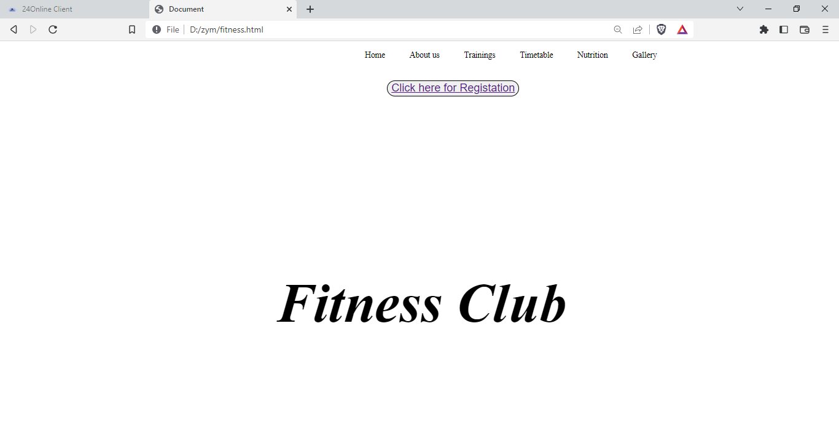

**Output of about us:-**

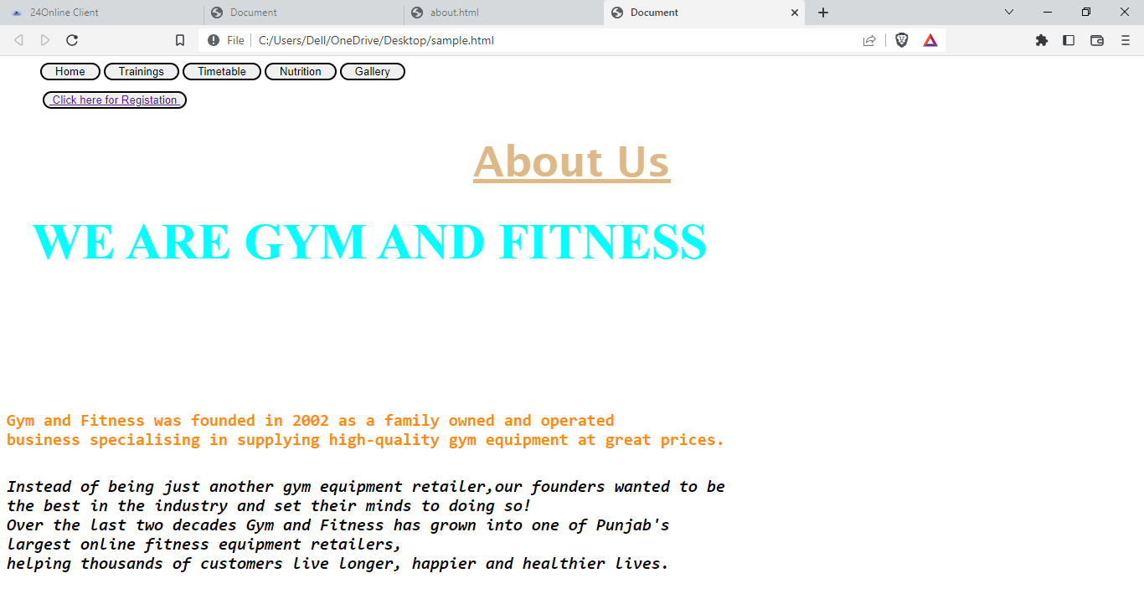

**Output of types of trainings:-**

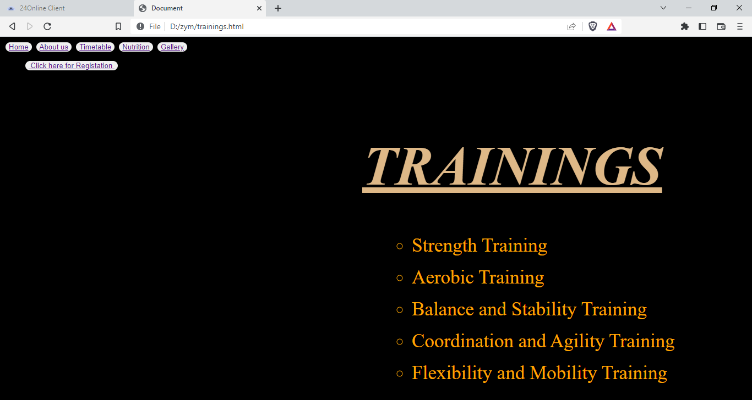

Output of nutrition:-

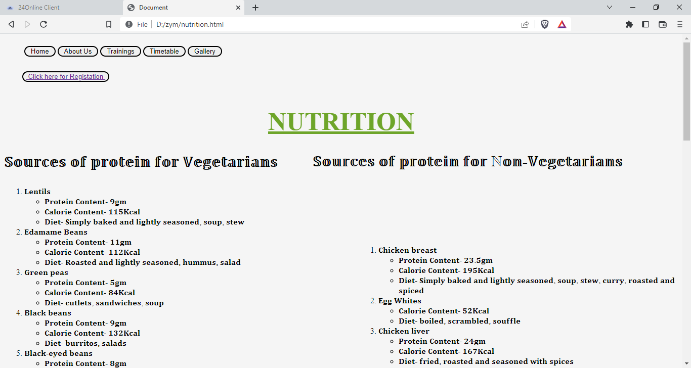

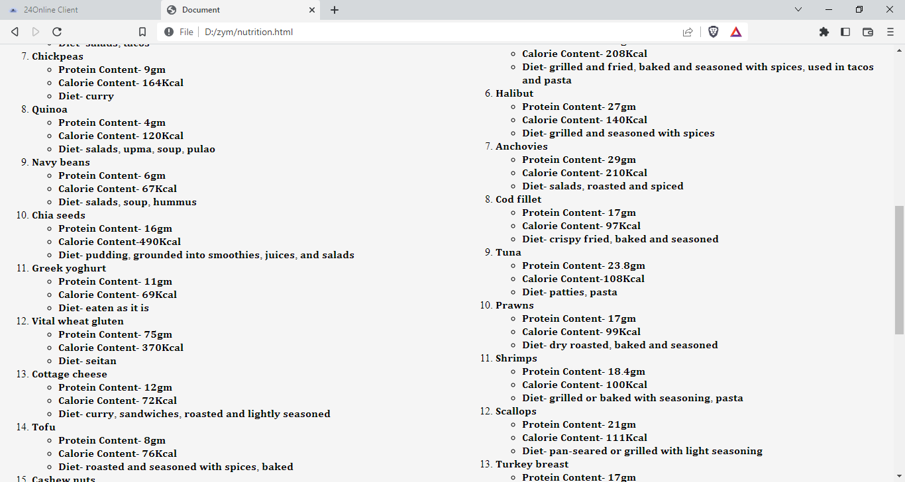

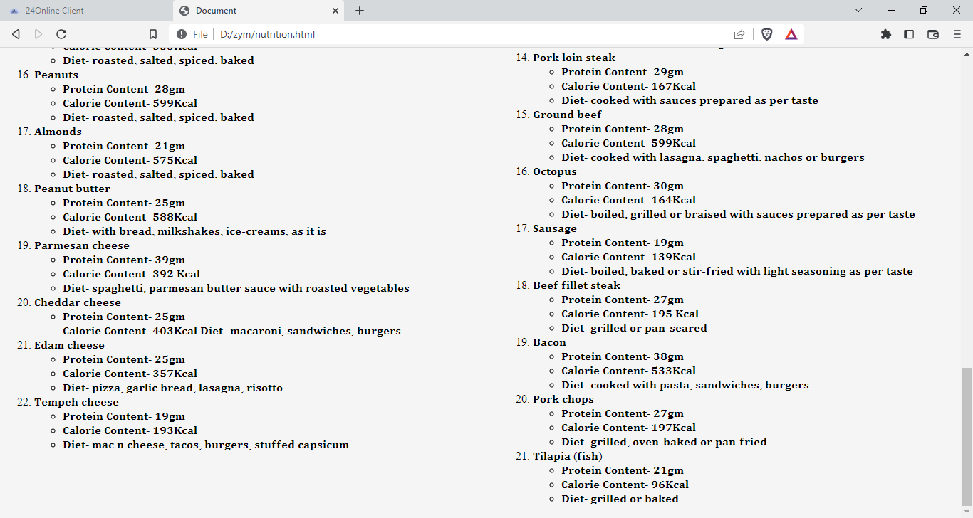

Output of registration:-

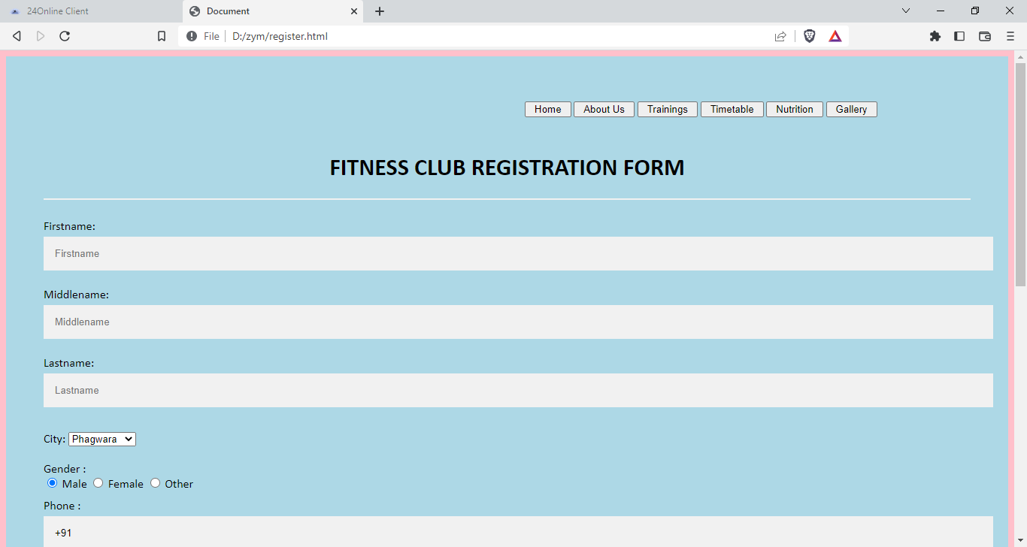

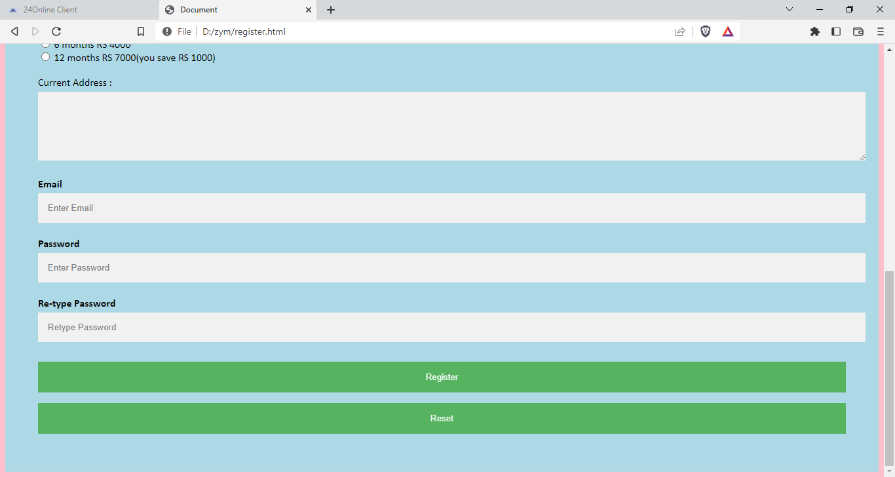

***REFRENCES:-***

We have used different websites during our project here are some references to that.

1. Wikipedia

2. GeeksForGeeks https://www.geeksforgeeks.org/

3.w3 schools.org